Plan De Pruebas

Clientes

Crear Cliente

CURL:
curl --location 'http://localhost:8084/api/clientes' \
--header 'Content-Type: application/json' \
--data '{
"customerId": "CUST00022",
"name": "Jose Lema",
"gender": "Masculino",
"age": 20,
"identification": "1234567001",
"address": "Otavalo sn y principal",
"phone": "098254785",
"password": "1234",
"state": true
}'

RESPONSE:
{
"customerId": "CUST00022",
"name": "Jose Lema",
"gender": "Masculino",
"age": 20,
"identification": "1234567001",
"address": "Otavalo sn y principal",
"phone": "098254785",
"password": "1234",
"state": true
}

POSTMAN:
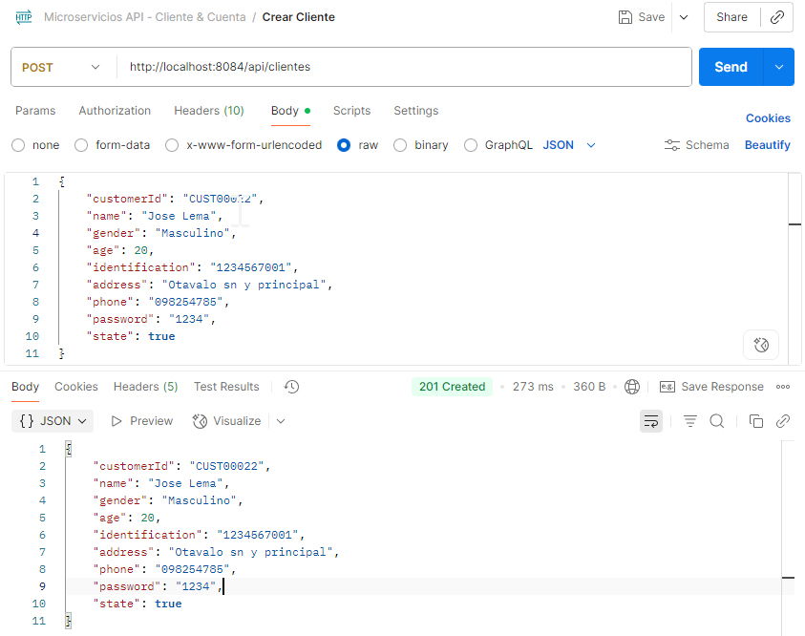

Actualizar Cliente

CURL:
curl --location --request PUT 'http://localhost:8084/api/clientes/CUST0022' \
--header 'Content-Type: application/json' \
--data '{
"address": "Pillaro San Miguelito",
"phone": "0980298828",
"state": true
}'

RESPONSE:
{
"customerId": "CUST00022",
"name": "Jose Lema",
"gender": "Masculino",
"age": 20,
"identification": "1234567001",
"address": "Pillaro San Miguelito",
"phone": "0980298828",
"password": "1234",
"state": true
}

POSTMAN:
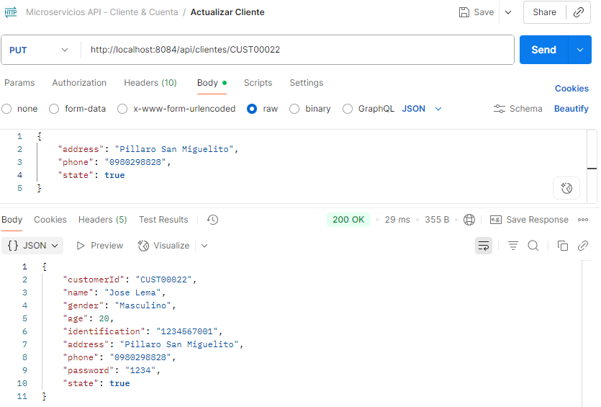

Consultar Cliente por ClienteId

CURL:
curl --location 'http://localhost:8084/api/clientes/CUST00022' \
--header 'Content-Type: application/json' \
--data ''
RESPONSE:
{
"customerId": "CUST00022",
"name": "Jose Lema",
"gender": "Masculino",
"age": 20,
"identification": "1234567001",
"address": "Pillaro San Miguelito",
"phone": "0980298828",
"password": "1234",
"state": true
}

POSTMAN:
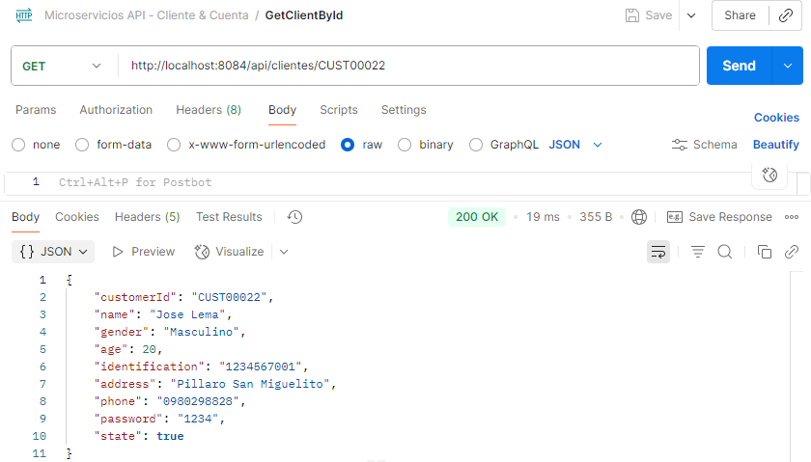

Eliminar Cliente

CURL:
curl --location --request DELETE 'http://localhost:8080/api/clientes/CUST0001' \
--header 'Content-Type: application/json'
POSTMAN:
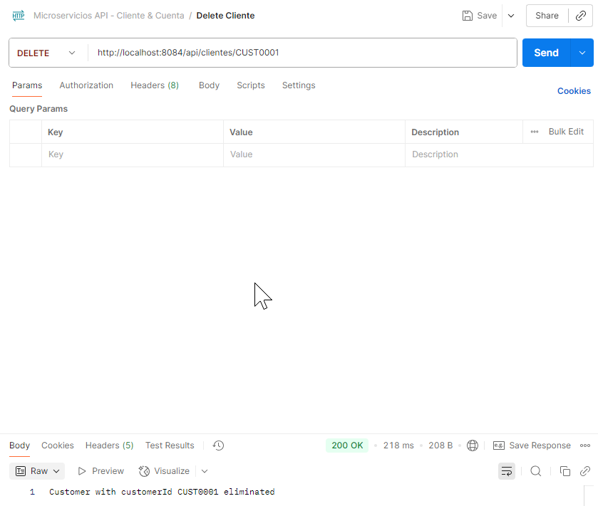

Cuentas

Crear Cuenta
CURL:

curl --location 'http://localhost:8085/api/
cuentas' \
--header 'Content-Type: application/json' \
--data '{
"accountNumber": "478758",
"accountType": "Ahorros",
"initialBalance": 2000,
"state": true,
"customerId": "CUST00022"
}'

RESPONSE:
{
"id": 1,
"accountNumber": "478758",
"accountType": "Ahorros",
"initialBalance": 2000,
"state": true,
"customerId": "CUST00022",
"availableBalance": 2000
}

POSTMAN:
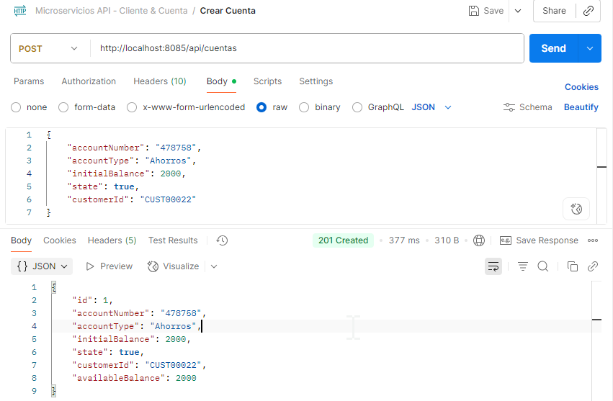

Actualizar Cuenta
CURL:
curl --location --request PATCH 'http://localhost:8085/api/cuentas/478758' \
--header 'Content-Type: application/json' \
--data '{
"state": false
}'
RESPONSE:
{
"id": 1,
"accountNumber": "478758",
"accountType": "Ahorros",
"initialBalance": 2000.00,
"state": false,
"customerId": "CUST00022",
"availableBalance": 2000.00
}

POSTMAN:
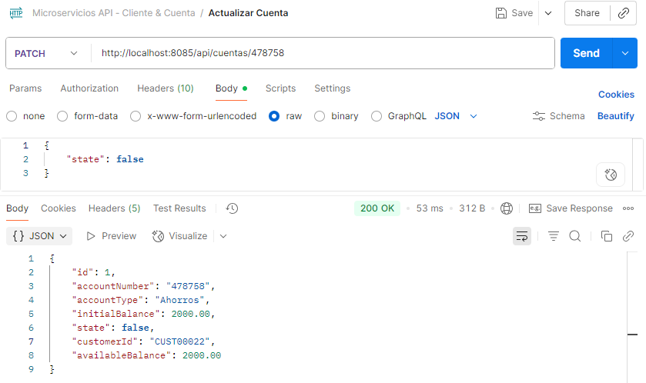

Consultar por Número de cuenta
CURL:
curl --location 'http://localhost:8085/api/cuentas/478758' \
--header 'Content-Type: application/json' \
--data ''

RESPONSE:
{
"id": 1,
"accountNumber": "478758",
"accountType": "Ahorros",
"initialBalance": 2000.00,
"state": false,
"customerId": "CUST00022",
"availableBalance": 2000.00
}

POSTMAN:
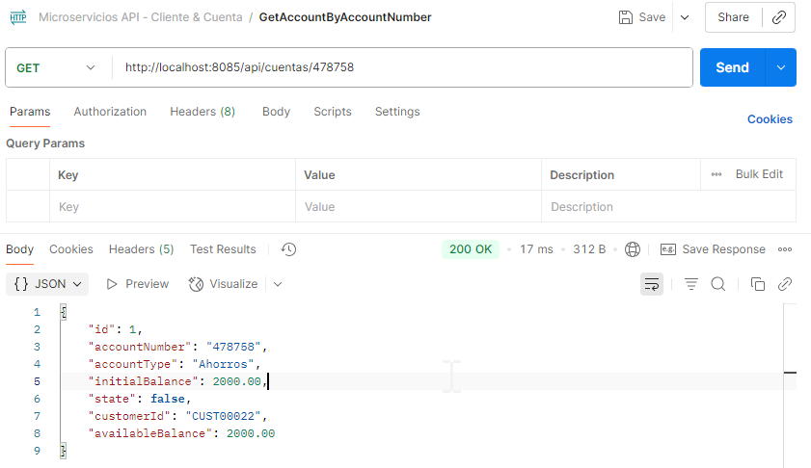

Eliminar Cuenta
CURL:
curl --location --request DELETE 'http://localhost:8085/api/cuentas/478758' \
--header 'Content-Type: application/json'
POSTMAN:
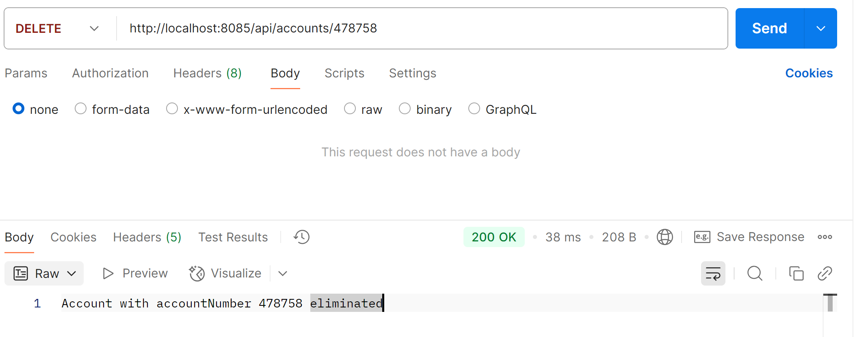

Movimientos

Crear movimiento
CURL:
curl --location 'http://localhost:8085/api/movimientos' \
--header 'Content-Type: application/json' \
--data '{
"accountNumber": "478758",
"movementType": "RETIRO",
"amount": -575
}'

RESPONSE:
{
"id": 1,
"date": "2025-09-22T21:26:46.051361307",
"movementType": "RETIRO",
"amount": -575,
"balance": 1425.00,
"accountNumber": "478758"
}

POSTMAN:
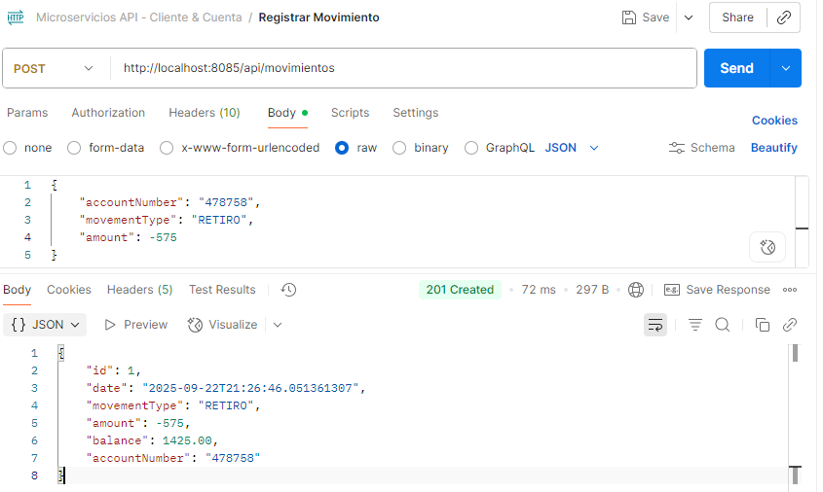

Crear movimiento con saldo no disponible
CURL:
curl --location 'http://localhost:8085/api/movimientos' \
--header 'Content-Type: application/json' \
--data '{
"accountNumber": "478758",
"movementType": "RETIRO",
"amount": -5750
}'
RESPONSE:
{
"timestamp": "2025-09-22T21:27:57.485058748",
"status": 400,
"error": "Bad Request",
"message": "Saldo no disponible",
"path": "/api/movimientos"
}

POSTMAN:
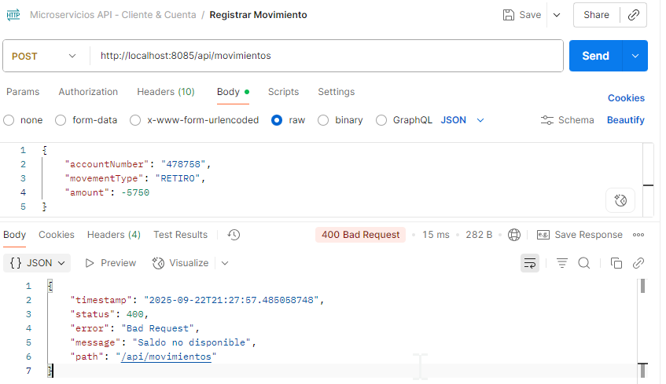

Reporte
CURL:
curl --location 'http://localhost:8085/api/movimientos/reportes?desde=2025-09-22T00%3A00%3A00&hasta=2025-09-22T23%3A59%3A59&customer=CUST00023'

RESPONSE:
[
{
"date": "22/09/2025",
"customerName": "Marianela Montalvo",
"accountNumber": "225487",
"accountType": "Corriente",
"initialBalance": 100.00,
"state": true,
"movement": 600.00,
"availableBalance": 700.00
},
{
"date": "22/09/2025",
"customerName": "Marianela Montalvo",
"accountNumber": "496825",
"accountType": "Ahorros",
"initialBalance": 540.00,
"state": true,
"movement": -540.00,
"availableBalance": 0.00
}
]

POSTMAN:
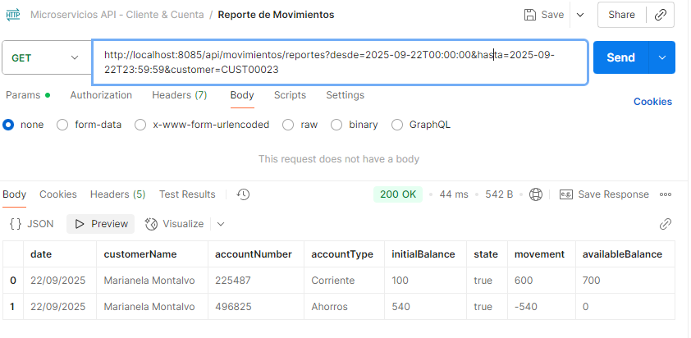

TEST

Crear Cliente
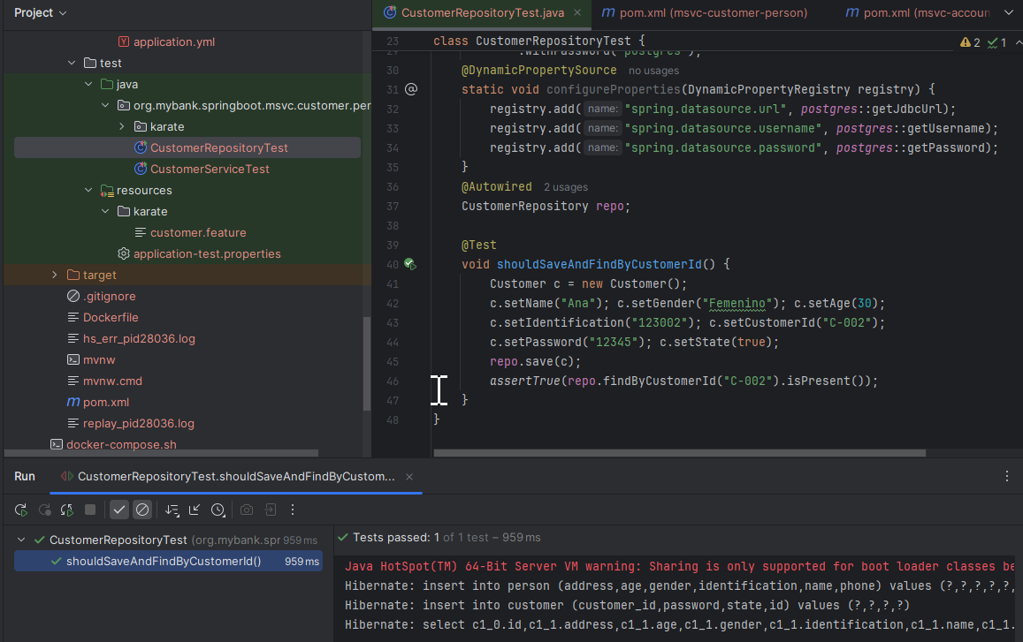

Obtener Cliente
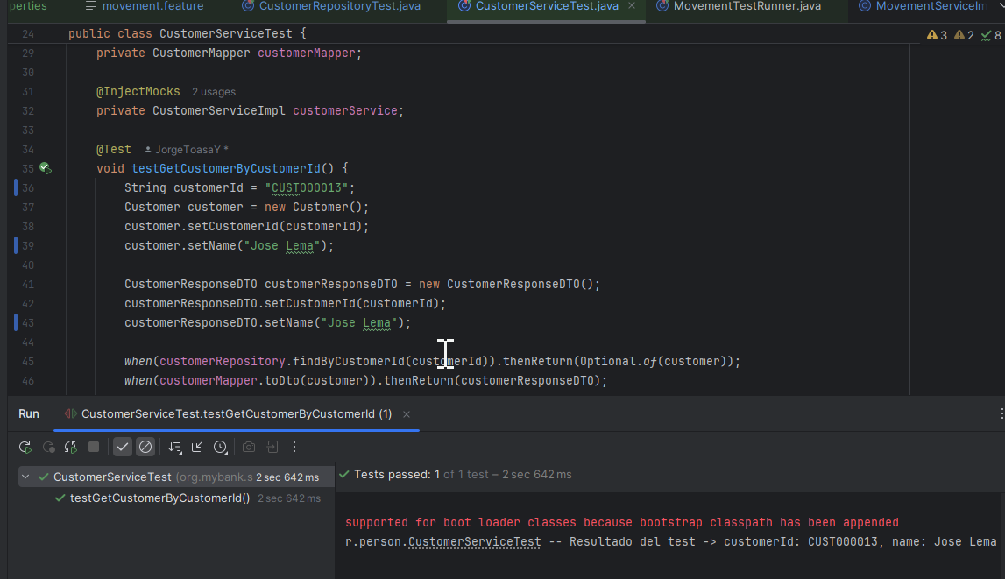

Crear Cuenta y movimientos
